# Lab 12 – Introduction to PSCPICE

## Exercise

### Exercise 1

Design the given below circuit

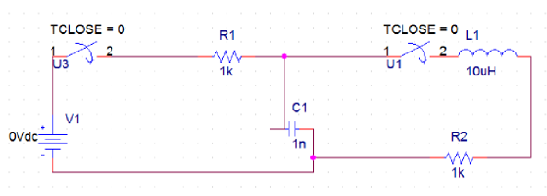

Figure 12-16

**Circuit:**

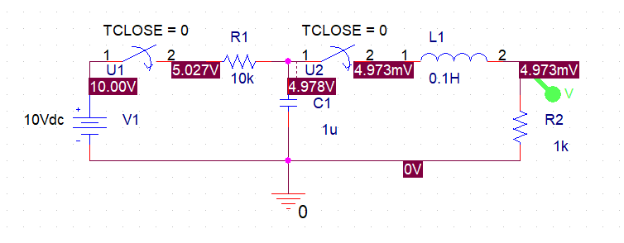

**Output-Wave:**

